**EDITOR TOOLS**

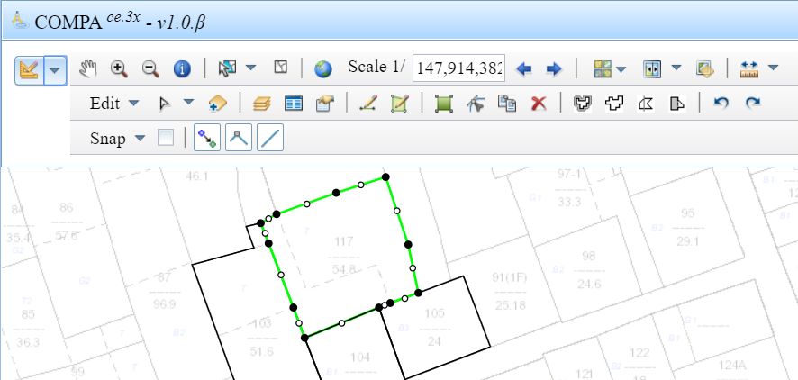

**Function bars:** Standard, Editor, Snapping

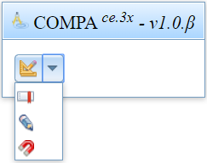

1. **Standard tools**

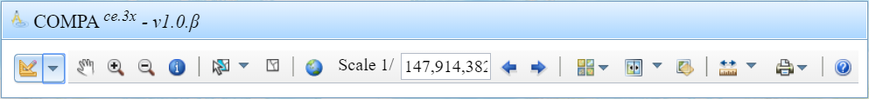

|  |  |  |
| --- | --- | --- |
| Pan | E:\vinhpt\OldProjects\compa\vh\awt\css\pan.png |  |
| Zoom In | E:\vinhpt\OldProjects\compa\vh\awt\css\zoomin.png |  |
| Zoom Out | E:\vinhpt\OldProjects\compa\vh\awt\css\zoomout.png |  |
| Identify | E:\vinhpt\OldProjects\compa\vh\awt\css\identify.png |  |
| Select | E:\vinhpt\OldProjects\compa\vh\awt\css\select.png | E:\vinhpt\OldProjects\compa\images\screen6.png |
| Clear Select | E:\vinhpt\OldProjects\compa\vh\awt\css\unselect.png |  |
| Fullextent | E:\vinhpt\OldProjects\compa\vh\awt\css\fullextent.png |  |
| Scale | E:\vinhpt\OldProjects\compa\images\screen3.png |  |
| Previous | E:\vinhpt\OldProjects\compa\vh\awt\css\back.png |  |
| Next | E:\vinhpt\OldProjects\compa\vh\awt\css\next.png |  |
| Basemap | E:\vinhpt\OldProjects\compa\vh\awt\css\basemap.png |  |
| Swipe | E:\vinhpt\OldProjects\compa\vh\awt\css\swipe.png | E:\vinhpt\OldProjects\compa\images\screen7.png E:\vinhpt\OldProjects\compa\images\screen8.png |
| Transparent | E:\vinhpt\OldProjects\compa\vh\awt\css\transparent.png | E:\vinhpt\OldProjects\compa\images\screen9.png |
| Measure | E:\vinhpt\OldProjects\compa\vh\awt\css\measure.png | E:\vinhpt\OldProjects\compa\images\screen10.png |
| Print | E:\vinhpt\OldProjects\compa\vh\awt\css\print.png | E:\vinhpt\OldProjects\compa\images\screen11.png |
| Help | E:\vinhpt\OldProjects\compa\vh\awt\css\help.png |  |

1. **Edit tools**

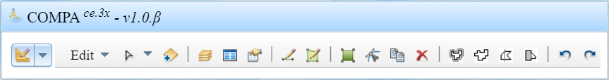

|  |  |  |
| --- | --- | --- |
| Edit menu | Check out for editing | E:\vinhpt\OldProjects\compa\images\screen5.png E:\vinhpt\OldProjects\compa\images\screen13.png |
| Select | E:\vinhpt\OldProjects\compa\vh\awt\css\editselect.png | E:\vinhpt\OldProjects\compa\images\screen21.png |
| Layers controls |  | E:\vinhpt\OldProjects\compa\images\screen17.png E:\vinhpt\OldProjects\compa\images\screen14.png |
| Attributes | E:\vinhpt\OldProjects\compa\vh\awt\css\attribute.png | E:\vinhpt\OldProjects\compa\images\screen15.png |
| Property | E:\vinhpt\OldProjects\compa\vh\awt\css\property.png | E:\vinhpt\OldProjects\compa\images\screen16.png |
| New Feature | E:\vinhpt\OldProjects\compa\vh\awt\css\pen.png | E:\vinhpt\OldProjects\compa\images\screen29.png |
| Sketch | Length | E:\vinhpt\OldProjects\compa\images\screen30.png |
| Angle | E:\vinhpt\OldProjects\compa\images\screen31.png |
| Parallel | E:\vinhpt\OldProjects\compa\images\screen32.png |
| Perpendicular | E:\vinhpt\OldProjects\compa\images\screen33.png |
| Extent | E:\vinhpt\OldProjects\compa\images\screen34.png |
| At X, Y | E:\vinhpt\OldProjects\compa\images\screen35.png |
| AutoComplete | E:\vinhpt\OldProjects\compa\vh\awt\css\autopolygon.png | E:\vinhpt\OldProjects\compa\images\screen18.png |
| Move/Scale/Rotate | E:\vinhpt\OldProjects\compa\vh\awt\css\move.png | E:\vinhpt\OldProjects\compa\images\screen19.png |
| Edit vertex | E:\vinhpt\OldProjects\compa\vh\awt\css\editvertex.png | E:\vinhpt\OldProjects\compa\images\screen20.png E:\vinhpt\OldProjects\compa\images\screen36.png E:\vinhpt\OldProjects\compa\images\screen37.png |
|  | Edge Length | E:\vinhpt\OldProjects\compa\images\screen38.png |
| Duplicate | E:\vinhpt\OldProjects\compa\vh\awt\css\duplicate.png |  |
| Delete | E:\vinhpt\OldProjects\compa\vh\awt\css\delete.png |  |
| Buffer | E:\vinhpt\OldProjects\compa\vh\awt\css\buffer.png | E:\vinhpt\OldProjects\compa\images\screen22.png |
| Merge | E:\vinhpt\OldProjects\compa\vh\awt\css\merge.png | E:\vinhpt\OldProjects\compa\images\screen24.png |
| Split | E:\vinhpt\OldProjects\compa\vh\awt\css\split.png | E:\vinhpt\OldProjects\compa\images\screen23.png |
| Reshape | E:\vinhpt\OldProjects\compa\vh\awt\css\reshape.png | E:\vinhpt\OldProjects\compa\images\screen25.png |
| Undo | E:\vinhpt\OldProjects\compa\vh\awt\css\undo.png |  |
| Redo | E:\vinhpt\OldProjects\compa\vh\awt\css\redo.png |  |